School of Information Sciences
(A Constituent Institute of Manipal University)



Title: SOIS student admission demography

Sachin B K. | 171046023
Sumanth S. | 171046020

Course: ME- Big Data and Data Analytics

Guide: Deepak Rao

CONTENTS
1. Abstract
2. Introduction
3. Specifications
4. Design
5. Analysis
6. Results
7. Scope for further work
8. Individual contribution

ABSTRACT

The student admission demographic information is used for “predictive analytics”. The details of the student data like Name, Date of birth, Age, Address, Marks, Ranking and B.E or B-Tec college name collected. By analysing these data of students and creating the graphical format. It enables decision makers to see analytics presented visually. So, they can grasp difficult concepts.

INTRODUCTION

The age of big data is now coming. But the traditional data analytics may not be able to handle such large quantities of data. The question that arises now is, how to develop a high-performance platform to efficiently analyse the big data and how to develop an appropriate model. To deeply discuss this issue, this project begins with a data collection, data analysis, followed by data visualization.

We gathered the required data set from the office of the SOIS department. For the analysis and visualization, we clean the collected dataset into the requirements. We took some of the major questions based on the dataset given and we analysed it. For the visualization part we plotted some pie and bar graph on datasets of students and can predict from which states more students are coming, gender and the results of students.

SPECIFICATIONS

The hardware and software requirements of the project are as follows:

Software Requirement:
1. Python:
Python is a high-level, interpreted, interactive and object-oriented scripting language. Python is designed to be highly readable. It uses English keywords frequently where as other languages use punctuation, and it has fewer syntactical constructions than other languages.
Python is Interpreted − Python is processed at runtime by the interpreter. You do not need to compile your program before executing it.
Python is Interactive − you can sit at a Python prompt and interact with the interpreter directly to write your programs.
Python is Object-Oriented − Python supports Object-Oriented style or technique of programming that encapsulates code within objects.
Python is a Beginner's Language − Python is a great language for the beginner-level programmers and supports the development of a wide range of applications from simple text processing to WWW browsers to games.

2. Pandas:
Pandas is an open source, BSD-licensed library providing high-performance, easy-to-use data structures and data analysis tools for the Python programming language.

3. Matplotlib (Plotting):

Matplotlib is a Python 2D plotting library which produces publication quality figures in variety of hardcopy formats and interactive environments across platforms. Matplotlib can be used in Python scripts, the Python and IPython shell, the jupyter notebook, web application servers, and four graphical user interface toolkits

DESIGN

Collect Raw data

Cleaning and processing of data
Data Analysis
Data Visualization

We gathered the required data set from the office of the SOIS department. For the analysis and visualization, we clean the collected dataset. We took some of the major questions based on the dataset given and we analysed it. And for the visualization part we plotted some pie and bar graph by using python packages like Numpy, Pandas and Matplotlib can predict from which states more students are coming, gender and the results of students

MODULES
States:
This analysis shows number of students coming from the different states in year 2005 to 2010

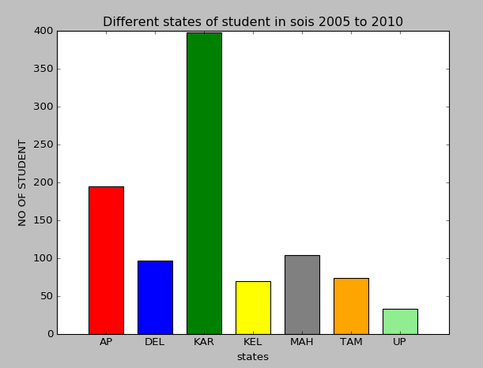
FIGURE NO -1

In this analysis maximum no of students are coming from KAR(Karnataka) and no students are less from AP(Andrapradesh), MAH(Maharashtra), DEL(Delhi), TAM(Tamilnadu), KEL(Kerla), UP (Uttar Pradesh).

Branch:
This analysis shows how many number of student present in different branches of SOIS in year 2005 to 2015.

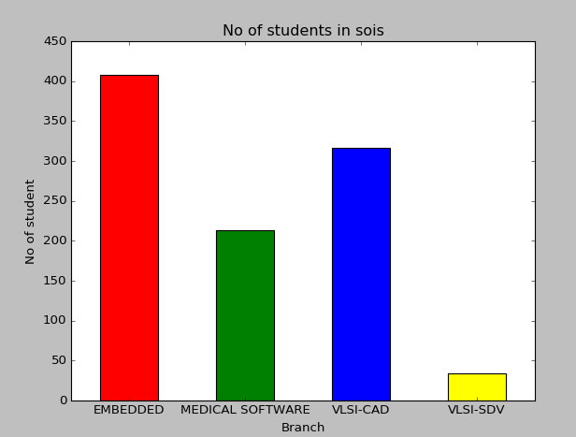
FIGURE NO -2

In this analysis maximum no of students are present in EMBEDDED compare to other branches.

Results:
This analysis shows the overall results of the student of SOIS from year 2005 to 2010.

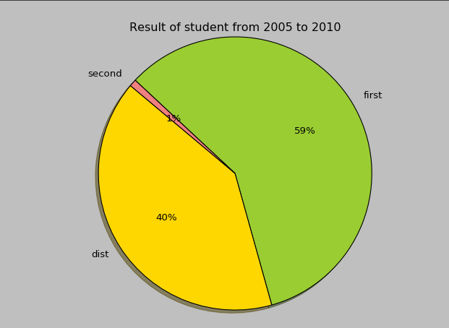
FIGURE NO -3

In this analysis 59% of students scored first class and 40% of students scored distinction and 1% of student scored second class.

Status:
This analysis shows the students who completed the course and students who left the course in between.

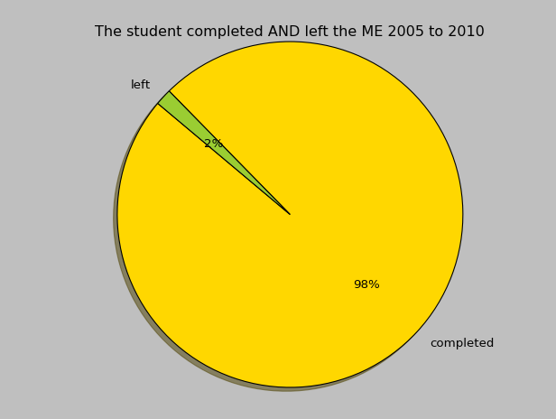
FIGURE NO -4

In this analysis 98% of students completed the course and 2% of students who left the course in between in the year 2005 to 2010

Gender:
This analysis shows number of male students and number of female students in SOIS from 2005 to 2010

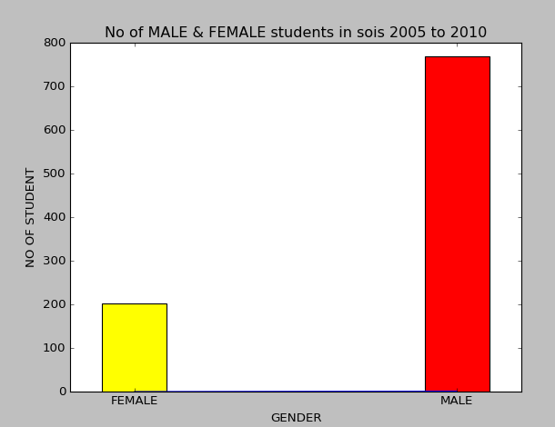
FIGURE NO -5

In this analysis there are 765 male students and 200 female students in year 2005 to 2010

ANALYSIS

We Analysed the SOIS student admission demography dataset by putting up some of the questions
1. Display the strength of students states from 2005-2010?
2. Display the results of the student of all the branches from 2005-2010?
3. Display the gender of students in percentage of all the branches from 2005-2010?
4. Display the status of students in percentage of all the branches from 2005-2010?
5. Display the strength students branch from 2005-2010?

We Visualized the SOIS student admission demography dataset by putting up some of the questions
1. Show the Visualization for the strength of student’s states from 2005-2010
2. Show the Visualization for results of the student of all the branches from 2005-2010
3. Show the Visualization for gender of the student of all the branches from 2005-2010
4. Show the Visualization for status of the student of all the branches from 2005-2010
5. Show the Visualization for strength students branch from 2005-2010

RESULT

We got output for Analysis and Visualization that we had done on student’s admission demography dataset. On the basis on Analysis and Visualization, we can predict how that took place in SOIS department since past 5 years. Can predict from which states more students are coming, gender and the results of students.

SCOPE OF FUTURE WORK

The scope of the future work in sois student admission demography provided with the district address and engineering marks of a students in dataset graph can be plotted for it. Which inference form which part of the district more students are going to come and clearly visualize the marks of the student before joining to the sois and marks increased after joining the SOIS.

INDIVIDUAL CONTRIBUTION

- Collected data from the SOIS office
- Manually Cleaned the dataset
- Worked on visualization part.

